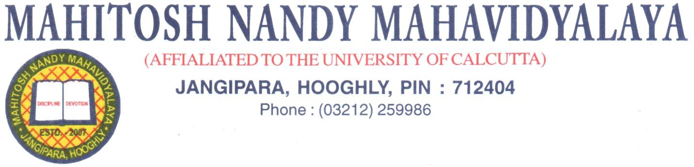
Dt. 28.02.2022
NOTICE

Students of Sem-1 can download their question Papers from the link given in College Website or University Website half an hour before the Exam Date and Time.
College Website: www.mahitoshnm.ac.in
University Website: www.cuug.in
www.cuug20.in
www.culibrary.ac.in

Subject wise mail Ids for on-line submission of scripts is given below. On-line submission of answer scripts will be allowed till half an hour after the end of the respective examinations. Off-line submission of answer scripts will be at the college office within half an hour after the end of the examination.

SI. NO. | MAIL ID
1 | bengalisem1@mahitoshnm.ac.in
2 | englishsem1@mahitoshnm.ac.in
3 | arabicsem1@mahitoshnm.ac.in
5 | sanskritsem1@mahitoshnm.ac.in
5 | philosophysem1@mahitoshnm.ac.in
6 | educationsem1@mahitoshnm.ac.in
7 | historysem1@mahitoshnm.ac.in
8 | polscsem1@mahitoshnm.ac.in
9 | geographysem1@mahitoshnm.ac.in
10 | aecc1sem1@mahitoshnm.ac.in
Principal
Mahitosh Nandy Mahavidyalaya

